Bury Art Society

Autumn Newsletter
2015
(2nd Edition)
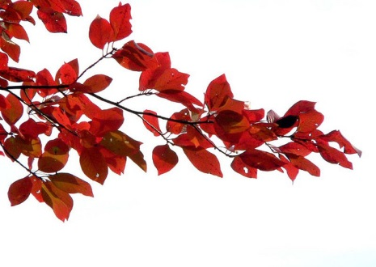

Membership

“At the Annual General Meeting held in May a number of attendees expressed concern about members who never attend weekly meetings but who exhibit at the Annual Exhibition at Bury Art Museum. This will be discussed further by the Committee at their first meeting.”

The above paragraph concluded the last Newsletter and subsequently the Committee have met to discuss the situation raising a number of points:

- Membership currently stands at 50+
- The number of entries at the Annual Exhibition is limited to 100 which, with everyone entering a maximum of 4 means that 50% will be rejected
- A majority of members attend meetings regularly and are very much involved with the running of the Society but may have work rejected in favour of the few members who do not attend meetings.
- Two members of the Committee are to discuss the situation more fully, perhaps with a view to altering the Constitution on “Membership” and report back to the full Committee to decide if any further action is necessary
- A reminder that subscriptions become due on 1st May and are paid annually

It is very gratifying that our membership continues to increase - gone are the days of 20 members and unlimited entries at the Art Gallery for the Annual Exhibition!

Michael Saxon, who currently manages our official web-site, would like to hand over the running and is more than willing to discuss and help with the organisation in the future. If anyone is interested would they contact me on buryartsoc@btinternet.com.

It is my sad duty to report that Ruth Hargreaves passed away recently. Ruth has been a supportive member of the Society since 1989 and our thoughts go to her family at this time.

Peggy Hargreaves
Secretary

